MRI-images after Summation of brain regions which are provided input to model:

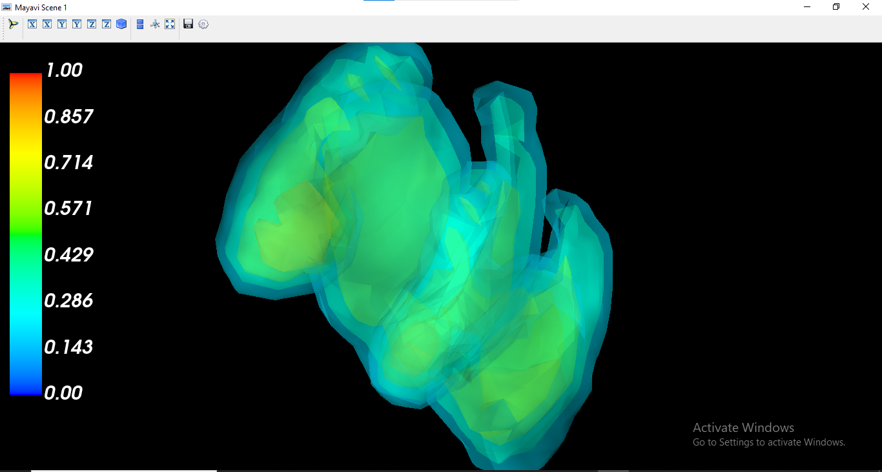

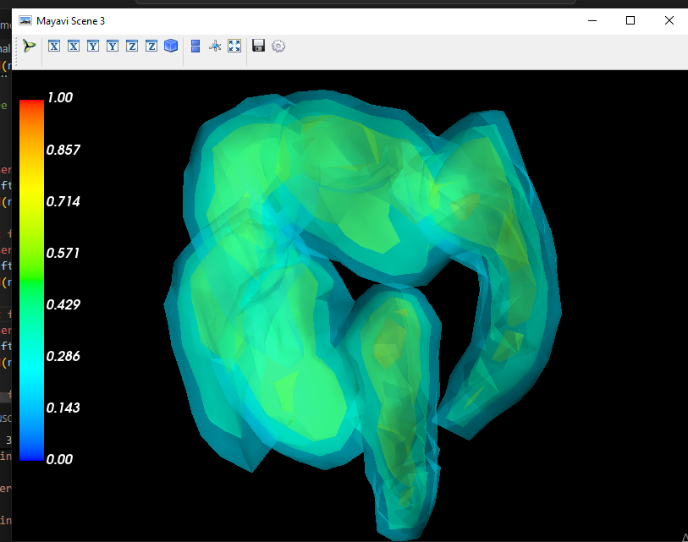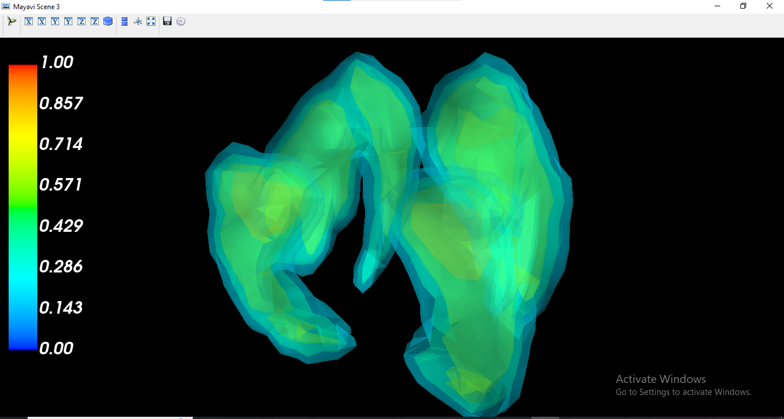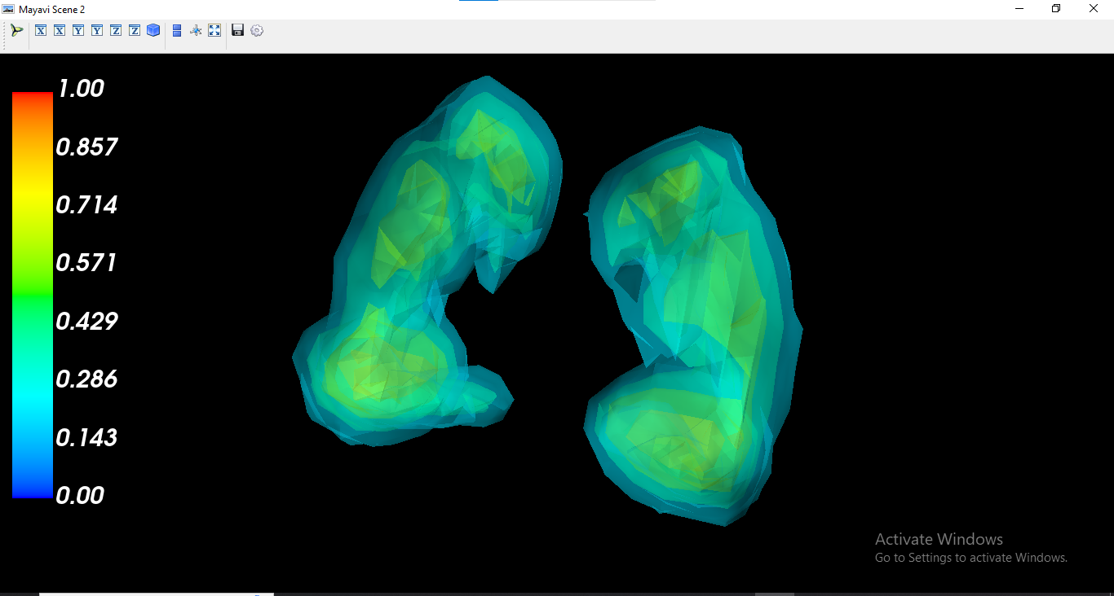CNN MODEL ADHD BY SUMMED BRAIN REGIONS :

Test Loss: 0.7768, Test Accuracy: 0.7500

Classification Report:

              precision    recall  f1-score   support

          C0       0.59      1.00      0.74        10

          C1       1.00      0.30      0.46        10

          C2       1.00      1.00      1.00        10

          C3       0.70      0.70      0.70        10

    accuracy                           0.75        40

   macro avg       0.82      0.75      0.73        40

weighted avg       0.82      0.75      0.73        40

Confusion Matrix:

[[10  0  0  0]

 [ 4  3  0  3]

 [ 0  0 10  0]

 [ 3  0  0  7]]

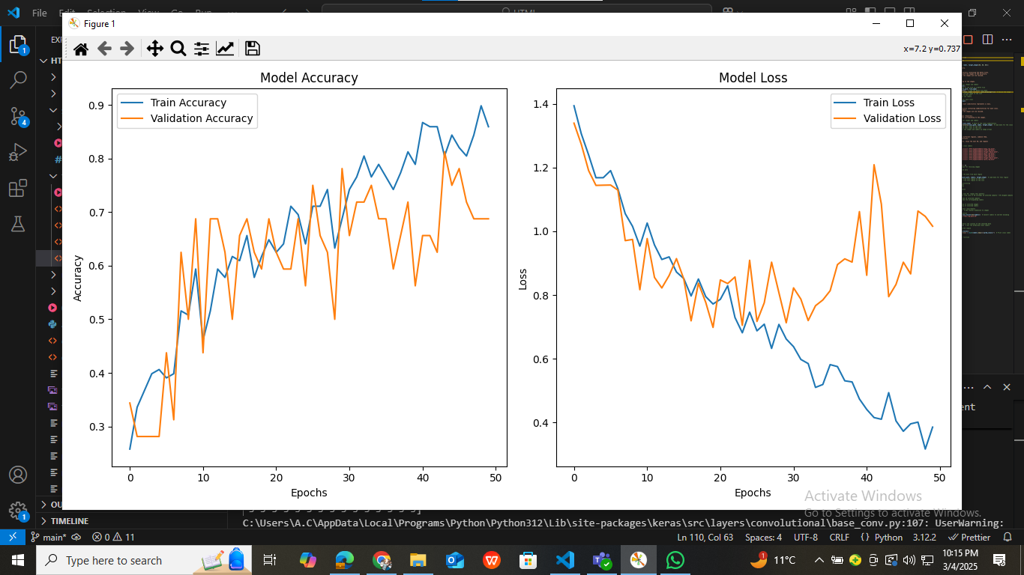

AFTER INPUTTING CLASS C0 FROM THE DATASET TO THE MODEL:

[0 0 0 0 0 0 0 0 0 0 0 0 0 0 0 0 0 0 0 0 0 0 0 0 0 0 0 0 0 0 0 0 0 0 0 0 0

 0 0 0 0 0 1 0 0 0 0 0 0 0]

It predicts 98% C0

AFTER INPUTTING CLASS C1 TO THE MODEL:

[0 3 1 0 0 0 1 0 1 0 1 0 0 1 1 1 1 1 1 1 3 1 1 0 1 3 1 3 1 1 3 1 0 1 1 0 0

 1 0 1 1 1 1 1 1 0 1 3 3 1]

It predicts 60% C1

AFTER INPUTTING CLASS C2 TO THE MODEL:

[2 2 2 2 2 2 2 2 2 2 2 2 2 2 2 2 2 2 2 2 2 2 2 2 2 2 2 2 2 2 2 2 2 2 2 2 2

 2 2 2 2 2 2 2 2 2 2 2 2 2]

It predicts 100% C2

AFTER INPUTTING CLASS C3 TO THE MODEL:

[3 3 3 3 3 3 3 3 3 3 3 3 3 3 3 3 3 3 3 0 3 0 3 0 3 3 3 3 1 3 0 3 0 3 3 3 3

 0 0 3 3 3 3 3 3 3 3 0 3 3]

It predicts 86% C3

62% accuracy Model:

Classification Report:

              precision    recall  f1-score   support

          C0       0.50      0.60      0.55        10

          C1       0.47      0.70      0.56        10

          C2       1.00      1.00      1.00        10

          C3       0.67      0.20      0.31        10

    accuracy                           0.62        40

   macro avg       0.66      0.62      0.60        40

weighted avg       0.66      0.62      0.60        40

Confusion Matrix:

[[ 6  4  0  0]

 [ 2  7  0  1]

 [ 0  0 10  0]

 [ 4  4  0  2]]

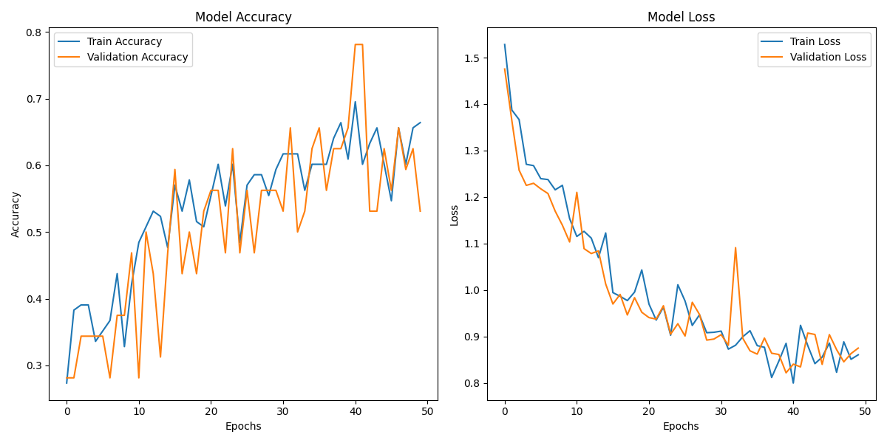

65%accuracy :

Classification Report:

              precision    recall  f1-score   support

          C0       0.55      0.60      0.57        10

          C1       0.50      0.60      0.55        10

          C2       1.00      1.00      1.00        10

          C3       0.57      0.40      0.47        10

    accuracy                           0.65        40

   macro avg       0.65      0.65      0.65        40

weighted avg       0.65      0.65      0.65        40

Confusion Matrix:

[[ 6  3  0  1]

 [ 2  6  0  2]

 [ 0  0 10  0]

 [ 3  3  0  4]]

WARNING:absl:You are saving your model as an HDF5 file via `model.save()` or `keras.saving.save_model(model)`. This file format is considered legacy. We recommend using instead the native Keras format, e.g. `model.save('my_model.keras')` or `keras.saving.save_model(model, 'my_model.keras')`.

